**Set of 3 Abstract Framed Art**

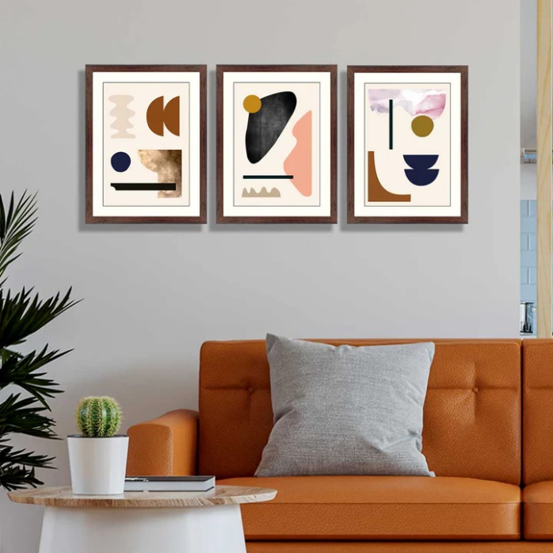This set of 3 abstract framed art pieces brings a modern and sophisticated touch to any space. Featuring flowing, hand-painted designs in warm tones of orange, yellow, and deep blue, the artwork is enhanced by delicate crane birds soaring gracefully across the scenes. The minimalist black frames provide a clean and polished look, allowing the vibrant colors and patterns to stand out. Paired with a cozy seating area adorned with striped and solid cushions in complementary hues, this arrangement creates a balanced and inviting atmosphere, perfect for elevating contemporary interiors.